|  |  |
| --- | --- |
| Date | 24 September 2022 |
| Team ID | PNT2022TMID34537 |
| Project Name | Project – Plasma Donor Application |
| Maximum Marks | 2 Marks |

Project Design Phase-I

**Problem Solution Fit**

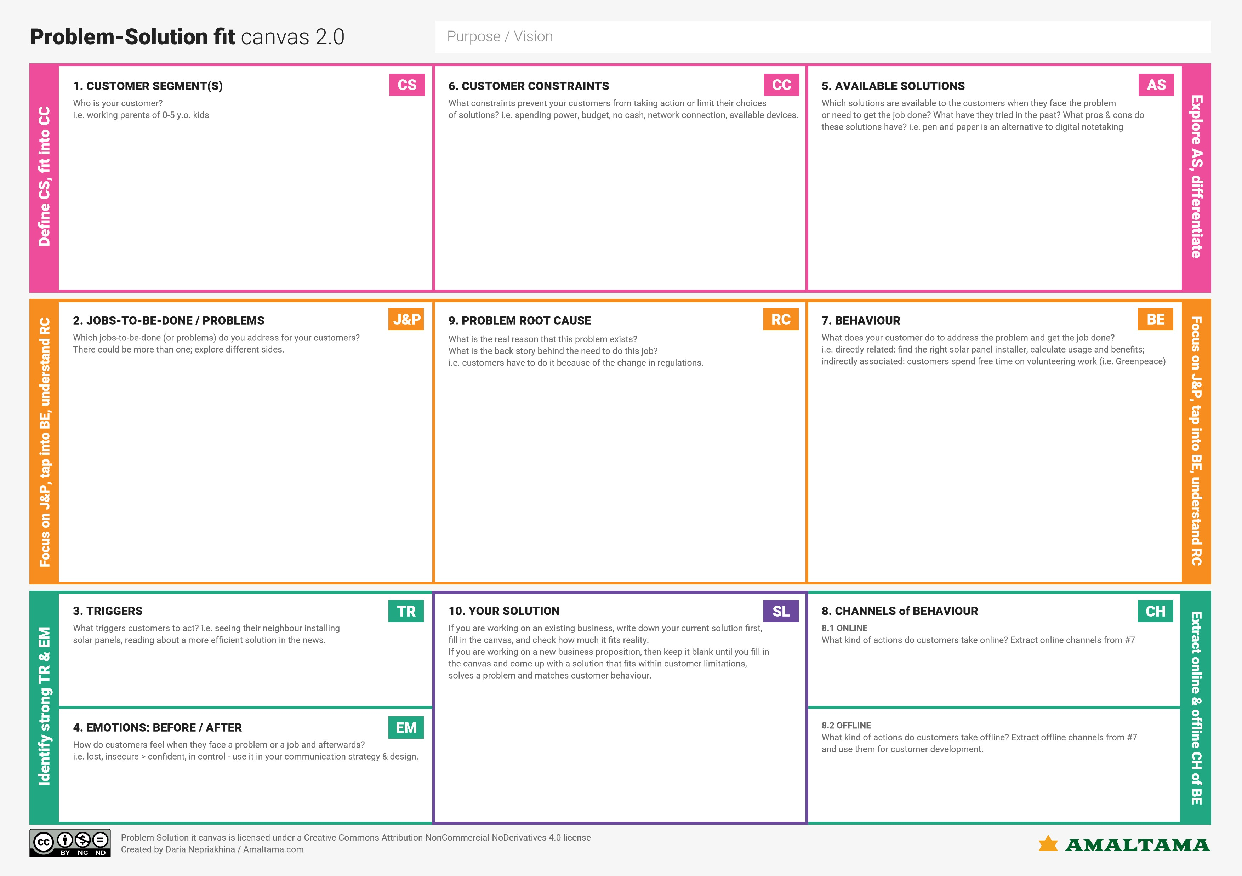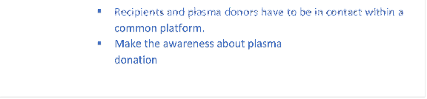

* Cloud works only with the internet connect so the offline users can only view their application.
* While users online, they can register their details for donating as well as requesting and can check for the nearest plasma donor.
* Connects Plasma recipients and Donors through the common platform.
* Spread the awareness about the Plasma Donation.
* Need of plasma triggers people to use this application.
* Find the right donor for plasma donation.
* This application works with the help of data that are stored in database of donors.
* Only few people know about the importance of plasma donation and so the lack of plasma donors is the root cause.
* Information needs to be collected about physical qualification of person who can gave plasma donation for shortlisting the registration.
* Data collected from users must property and securely stored.
* Proper instruction must be given for the donor while donating the plasma.
* Recipients and Plasma donors have to be in contact within a common planform.
* Make the awareness about plasma donation.
* Network Connection
* Availability of donors for the respective blood group
* Knowledge about application usage
* Hospital Management
* Patients
* Friends and Families of Patients
* People are mostly aware about blood donation and it’s importance and less aware about plasma donation.
* This application helps to spread the awareness on plasma donation about plasma donation.